**Data Mining Assignment –I**

**NAME: Anisha Khetan SEM: 6A USN: 1PE16CS022**

**DATASET NAME :- Nifty Pharma Index**

**DATASET VALUES**

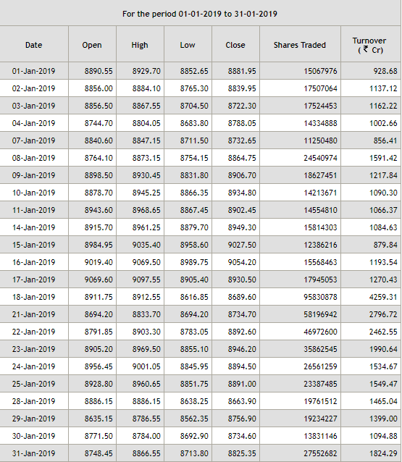

**OUTPUT : GRAPHS**

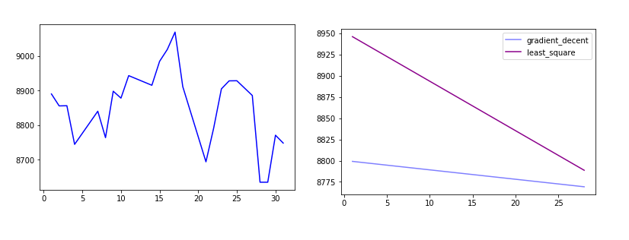

**OUTPUT: SCREENSHOTS**

**LEAST SQUARE METHOD**

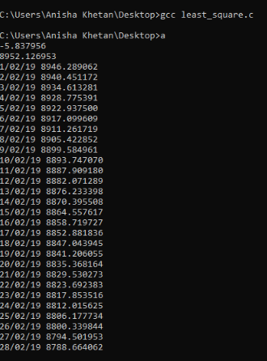

**GRADIENT DESCENT METHOD**

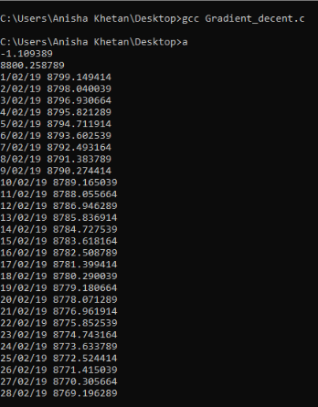

**ERROR VALUES FOR GRADIENT DESCENT**

